 Salestrail App Analysis
User side (Caller) App:
Opening: As soon as we enter the app all the permission are received from the user side properly and transparently with their consents.

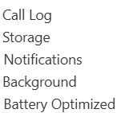
Permissions Asked:
After Login:
- Page-1Tracked Calls
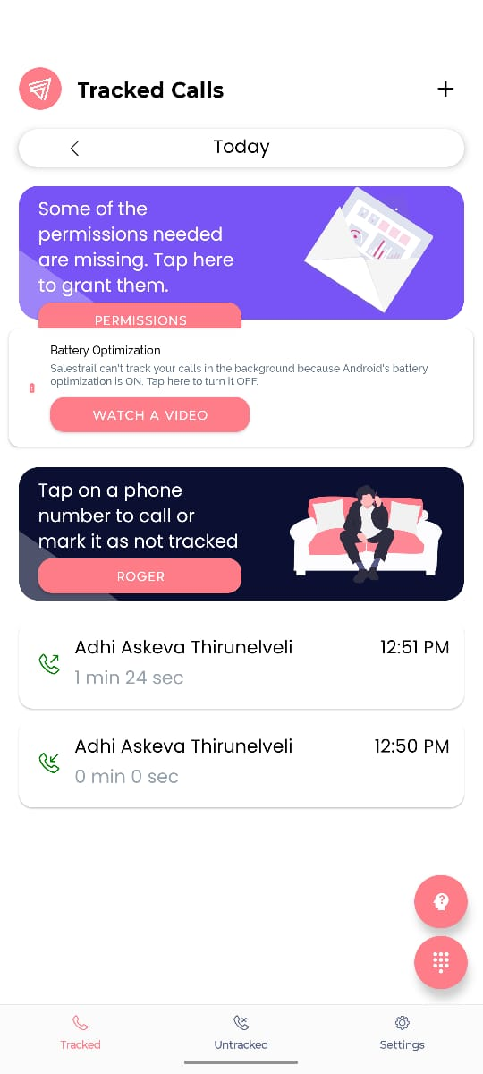
Details of the calls tracked, dialpad, Addition of call details manually at be added at the top

- Page-2 Add Tracked Call Page (Manual Addition of calls to be tracked)
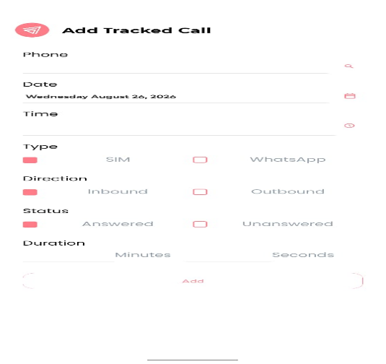
- Page-3Untracked Calls
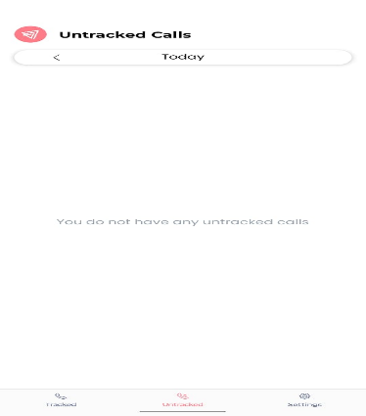
Calls received or dialled after the mentioned business time will be stored here and also has the option to change the status of the call to untrack.
- Page-4 Settings
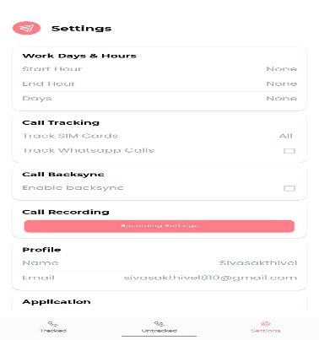
Setting Business Time
Profile and details of the Caller
Application version and permissions

Admin Side WebPage
Overview:
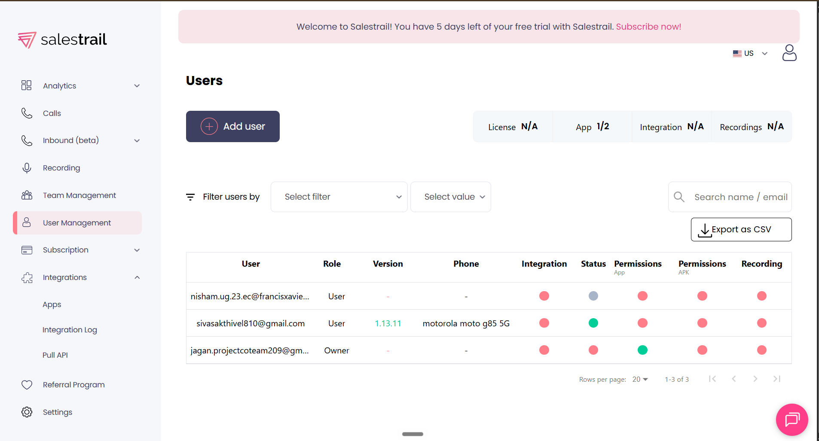

Analytics Page:

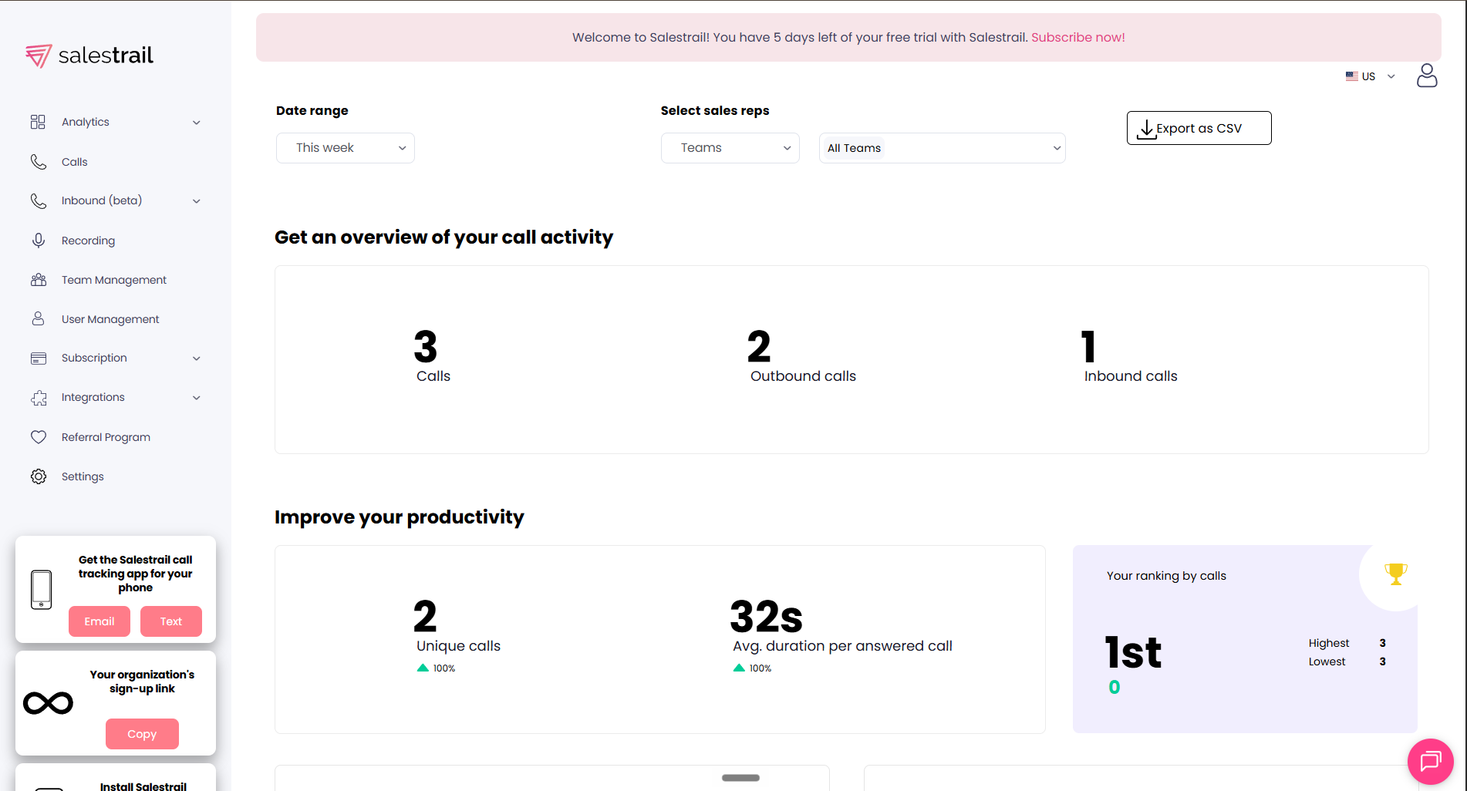

Calls Details Page:
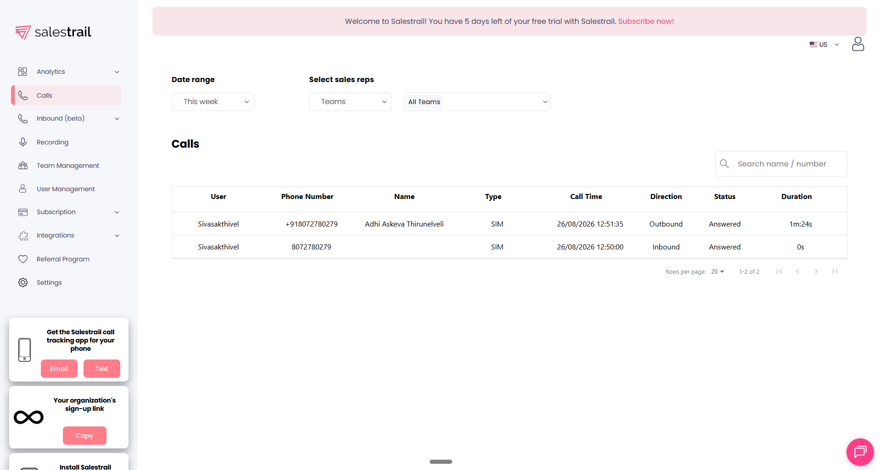

Recordings Page

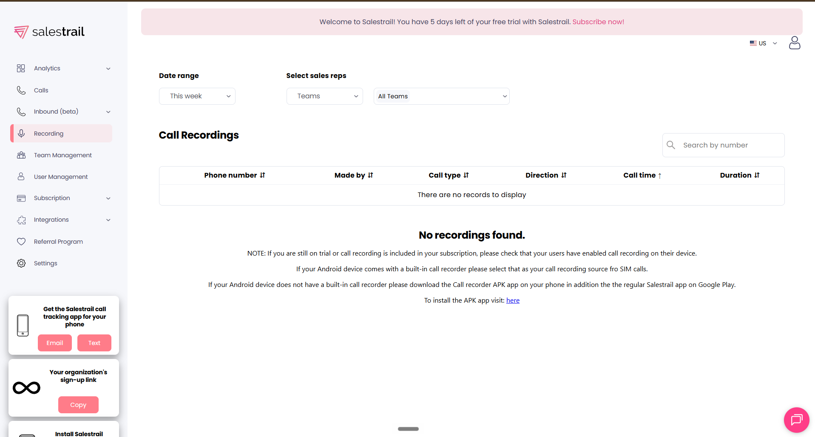

Team Management Page
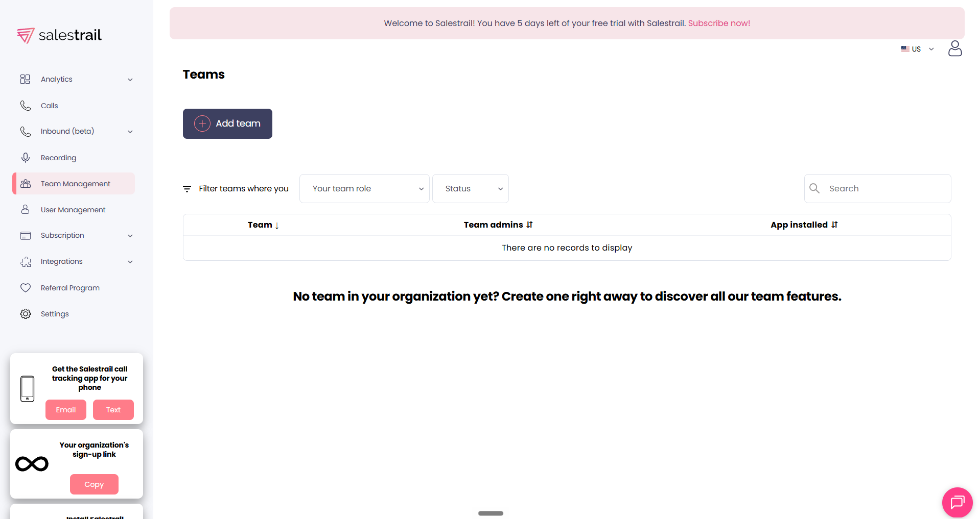

User (Callers Details) Page:
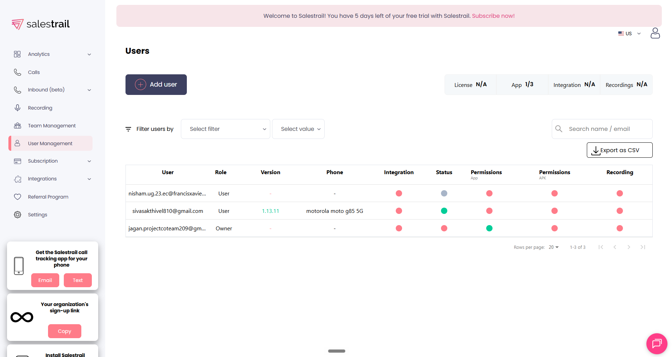

Things to Include in Our App:
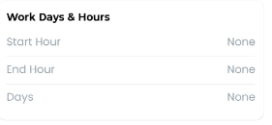
- add the business working time to enhance privacy

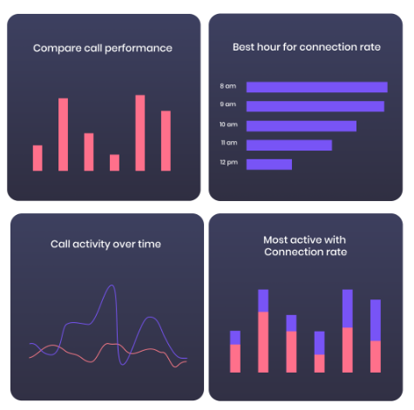
- add important key metrics like call quality ratio, and conversion ratio, dial to connect ratio.
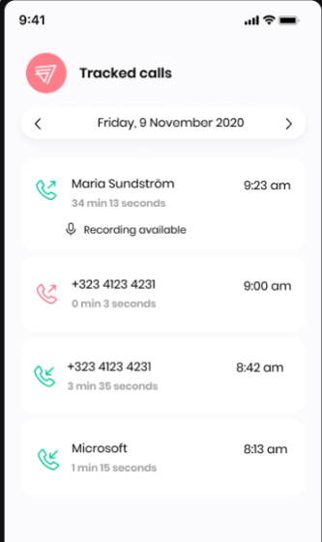
3) add the logo of AskEVA at each and every screen at left top to create branding impact and uniformity.
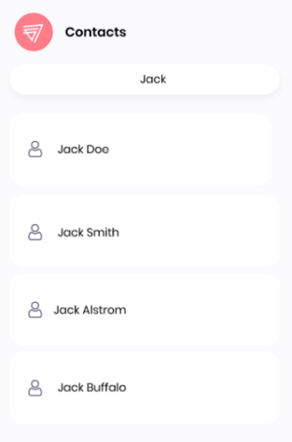

- Add Search for contacts and auto Sync of Contacts saved in the phone

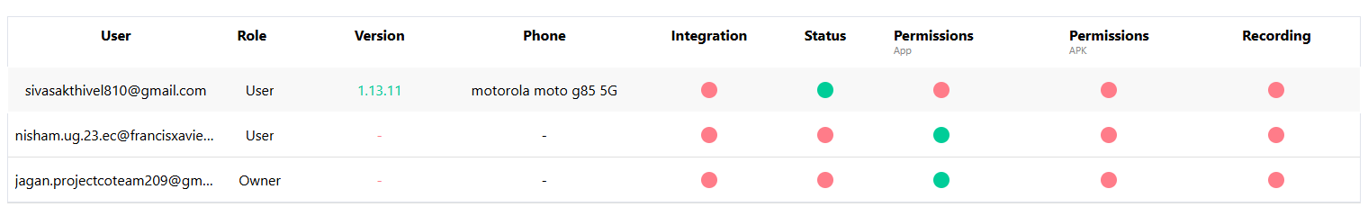

5)Addition of Live- Status tracking of the Callers in the Managers application
6) Show Transparent Permission Acquired from the Users for trust
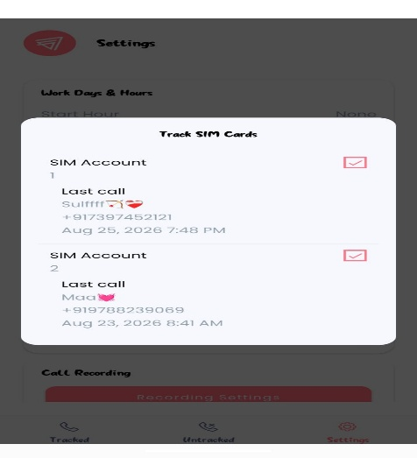
7) Currently the Selection of the SIM is present inside the settings page and not done initially so both sims are taken into tracking while the user has dual sim in his phone. So making the person to choose the sim initially during login itself would be great incase of device with dual sims.

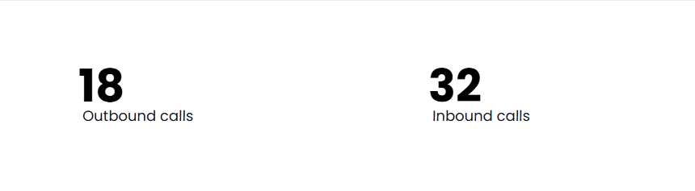
8)Use of Professional Wordings like Inbound and Outbound

9) Offline Sync option to not miss any call recordings even when we are offline
(If your phone is temporarily offline, Salestrail queues the call events and syncs them automatically when the connection returns.)

10)Filter option in recordings tab in manager to classify as Incoming and Outgoing.

